

**Summer Notes 2024**

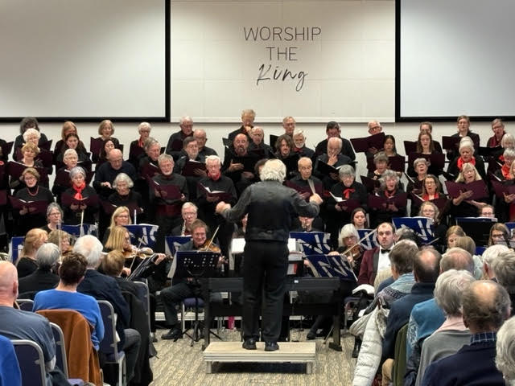

**Eversley Choir Concerts in 2024**

We had fantastic feedback from our audiences in Capernwray and St John’s Church. Here’s one response to our May concert.

*“I just wanted to say how much I enjoyed yesterday's concert. I thought the choir sang really well, with great variation of sound. The Faure was one of the best performances I have heard, and those soloists! Wow! The spirituals were also really good”*

We have an exciting programme planned for the next choir year and look forward to seeing as many of you as possible at our first rehearsal on **Monday 2nd September. This will be an open rehearsal. Please encourage singers to come along and join our choir.**

**Music and key dates for 2024/25**

* Monday 2nd September

*Rehearsals restart, 7 - 9.20pm at Borwick and Priest Hutton Memorial Hall (BPH). Rehearsals will continue weekly at BPH towards our Christmas concert*

* Monday 9th September

*AGM followed by choir rehearsal*

* Saturday 19th October

*Workshop 10am – 1pm looking at music for Capernwray. Associate singers for Capernwray will be invited. The workshop will be free to choir members*

* Monday 16th December

*Rehearsal for Christmas concert at St Thomas Church*

* Thursday 19th December

*Christmas Concert at 7pm in St Thomas Church, Milnthorpe. Music includes Britten: Rejoice in the Lamb and Haydn: St Nicolas Mass*

* No rehearsal on 23rd and 30th December
* Monday 6th January

*Rehearsals restart at BPH. Ian will be preparing the choir for the Capernwray concert and associate singers will be invited to attend as many rehearsals as possible before the concert*

* Thursday 20th February

*Additional rehearsal at BPH with orchestra to prepare for Capernwray concert*

* Saturday 1st March

*Capernwray concert in the afternoon with probable morning rehearsal. Music will include the Cherubini Requiem and Handel’s Zadok the Priest and The King Shall Rejoice*

* Sunday 11th May

*Spring concert in the afternoon at BPH.* “*Shakespeare to Shearing” – settings of English poetry*

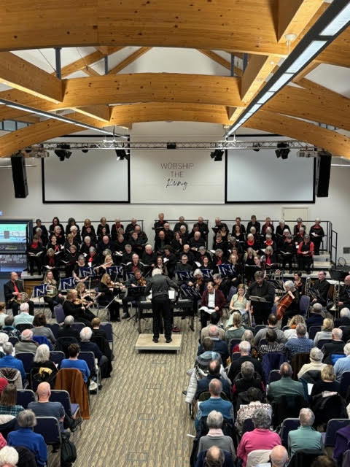

**Have a wonderful summer and see you soon**